Shem Katz  SSI Open Water Instructor · Dive Guide · Underwater Photographer  Currently in Puerto Escondido, Oaxaca, Mexico · Mexican residency visa with permission to work  shemkatz@hotmail.com · +52 987 100 5337 · Photography: @shemkatz · shemkatz.com (WIP) | 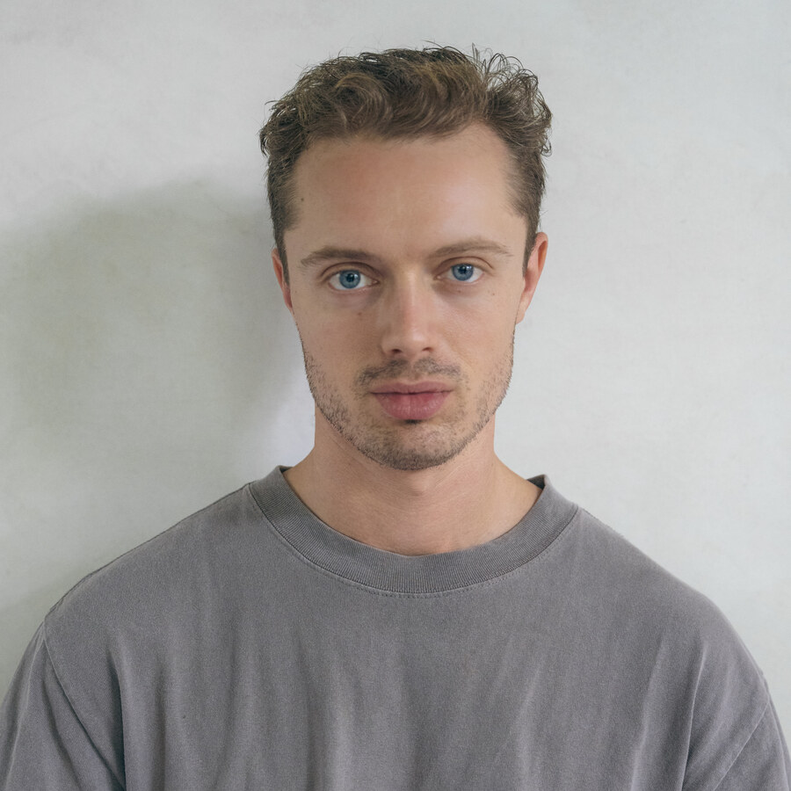

300+  LOGGED DIVES | Freelance Diving professional  + DATA SCIENTIST | 3  COUNTRIES WORKED | EN / ES / NL  LANGUAGES

PROFILE
Dive guide and underwater photographer, working seasons in Mexico and Curaçao. After five years as a data scientist, I took the leap and decided to persue my passions - the ocean and photography. Since doing so, I have permeantly resided in Mexico having fallen in love with the country. I am seeking new diving opportunities and cannot think of anything more exciting then diving in the best desitination in Mexico. Moreover, the month on-month off dynamic suits me well. My unique background in hospitality, banking, diving and photography provides me with a unique range of skills that I think could be an excellent attribute for Nautilus and allows me to connect with a wide range of customers.
DIVING EXPERIENCE
Dive Guide & Photographer | Cozumel, Mexico | Oct 2024 – Current
- Guided drift and deep dives on the Cozumel reefs.
- Daily diving operations, predominantly from the boat.
- Private underwater photo shoots.
- Seasonal work
Dive Guide, First Mate & Photographer | Curaçao | Mar – Sep 2025
- First mate to the captain: boat set-up, docking, cleaning and turnaround between trips.
- Guided shore and boat dives, and looked after guests on board throughout the day.
- Shot stills through the season, for guests and for the centre.
Underwater Content Creation | Fiji | Oct 2025
- 3 week content creation assignment
SKILLS
SSI Open Water Instructor | 300+ logged dives. Comfortable in various conditions.
Underwater photographer | Specialising in wide-angle photography predominantly working privately for clients.
Hospitality | Several years in bars and restaurants, latterly as manager.
Languages | English (native) · Spanish (conversational, used daily) · Dutch (conversational).
Data science | Five years of statistical modelling in Dutch banking and pensions; taught Python to colleagues and clients.
Education | MSc Actuarial Science and Mathematical Finance, University of Amsterdam. BSc Financial Mathematics, First Class.
UNDERWATER PHOTOGRAPHY
I shoot underwater and on land, and publish the work at shemkatz.com (work in progress) and on Instagram @shemkatz — reef life, night dives, wrecks and over-under splits. I’d love to incorporate this in collaboration with Nautilus.
BEFORE DIVING
Actuarial Consultant, ELAVV (2025 – present, remote) · Credit Risk Modeller, ABN AMRO (2021 – 2024), including leading a small team and defending technical work in a European Central Bank audit.
Available immediately · Happy to travel whenever a trip is due or relocate to Baja ·

